Democracy: A Journal of Ideas

A Fair Shake for Black Workers

We know why labor market racial discrimination exists. Do we have the will to fix it?
By Valerie Wilson William Darity Jr.
from Winter, No. 63 – 42 MIN READ

Tagged Discrimination Jobs Racism workers

• 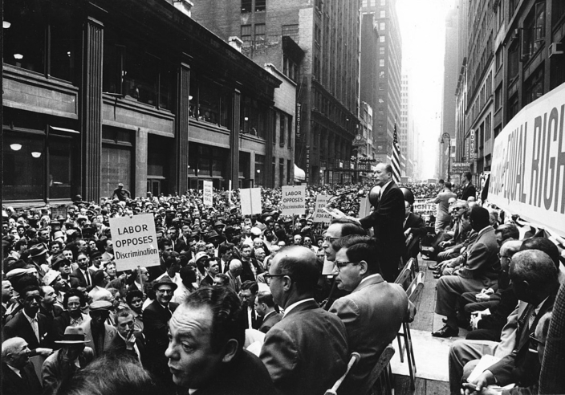
Photo by Kheel Centre via CC 2.0 -- Charles Zimmerman speaks at a civil rights rally in the New York Garment District, May 17, 1960.
This essay is adapted from a paper originally commissioned as part of the Economic Policy Institute’s Unequal Bargaining Power (UBP) initiative. The project was made possible because of a general operating grant from the Bernard and Anne Spitzer Charitable Trust and support from the William and Flora Hewlett Foundation.
The assumption of a perfectly competitive labor market is central to some of the most widely accepted theories in the field of labor economics. On the demand side of this market structure are many firms seeking to fill identical jobs. On the supply side are many workers who possess the same set of requisite skills for a given job opening, all of whom have perfect information about wages and job conditions, and are able to move their labor freely, or without cost. The equilibrium price and quantity of labor—the market wage and level of employment, respectively—are those at which the amount of labor supplied by workers is equal to the amount of labor demanded by firms. Workers are paid the marginal product of their labor and in the long run, such a perfectly competitive labor market is theoretically at “full employment” since all who are willing to work at the market wage can find a job that pays that wage.
Under these market conditions, employers are assumed to be wage takers. In other words, they are unable to hire or retain workers for less than the going market wage because no worker would willingly accept a job for less, when they could easily transfer their labor to a competing firm that pays the market wage. In such markets, any differences in wages must be due to differences in productivity-related human capital.
In reality however, labor market structures are far from perfectly competitive, and employers are rarely so powerless as to have no discretion in setting wages below marginal productivity or paying different wages to equally productive and qualified workers. Since there is no absolute empirical standard of full employment—a condition implied by perfect competition—economists often disagree over what the “full employment” unemployment rate is or should be. Nevertheless, the nation’s actual unemployment rate has frequently been above even the far too conservative Congressional Budget Office (CBO) estimates of the “natural rate of unemployment,” or non-accelerating rate of unemployment (NAIRU). This has more often been the case than not during the last 40 years, a period that is characterized by rising inequality. Since 1979, the monthly unemployment rate has been below 6 percent only approximately half of the time. In that same period of time, the Black unemployment rate has fallen below 6 percent for just a brief five months preceding the COVID-19 pandemic. Further, the Black unemployment rate has remained nearly double the national rate of unemployment, and racial wage gaps have widened.
The threat of unemployment, in combination with prohibitive conditions imposed by employer practices, public policy, incomplete information about job opportunities, or geographic immobility, mean that workers often cannot change jobs or employers easily and without cost. This imbalance of power between employers and employees disproportionately disadvantages Black workers when racial identity is used to assign privilege or disadvantage in the labor market context.
Persistent racial inequality in unemployment and wages are outcomes that have been ignored, dismissed, and remain unsatisfactorily explained by conventional economic theory. In the first section we summarize the data describing racial disparities in unemployment and wages. Next, we review the prevailing economic theories used to interpret racial inequalities in labor market outcomes and present challenges to and shortcomings of those theories. Finally, we present stratification economics as a more appropriate framework for understanding the imbalance of power inherent in the social structures that perpetuate racial inequality in labor market outcomes.

Racial Disparities in Unemployment
One of the most durable and defining features of the U.S. labor market is the large and persistent disparity in unemployment that exists between Black and white workers. This disparity is well-documented in decades of publicly reported official estimates from the Bureau of Labor Statistics, dating back to 1954 when the agency first began reporting rates of unemployment by race (i.e., white and nonwhite). In 1972, BLS began disaggregating the nonwhite unemployment rate and reporting an unemployment rate for Blacks alone. According to this measure, Black job seekers are about half as likely to secure employment during a consecutive 4-week search period as are white job seekers. As shown in Figure A, this is demonstrated by the fact that the ratio between the Black and white unemployment rates has consistently been about 2-to-1 since 1972. This pattern has persisted across multiple periods of economic growth and contraction, including at historically low rates of Black unemployment reached in 2019. After ten years of job growth, the Black unemployment rate reached an annual average of 6.1 percent in 2019 but was still twice as high as the white unemployment rate of 3.0 percent.
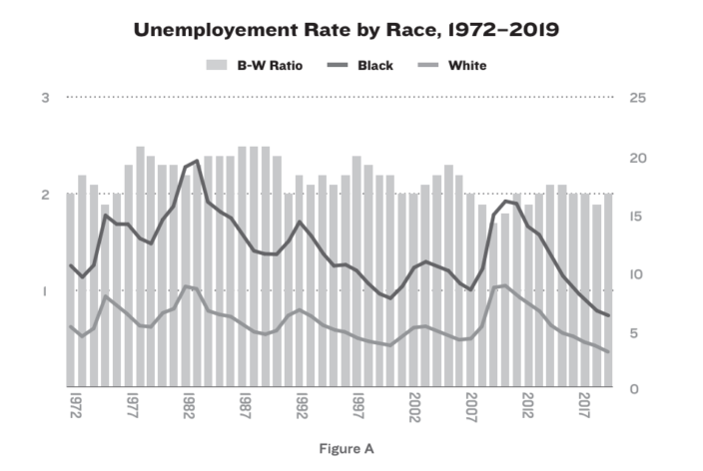
Attempts to explain the Black-white unemployment rate gap often cite observed average differences in human capital—particularly, education or skills—between Black and white workers as a primary reason for the disparity. While conventional human capital theory does not explain the presence of unemployment apart from wage or price rigidities, patterns of unemployment by educational attainment and age are clearly documented in national statistics. According to these data, those with higher levels of education and more potential work experience, as indicated by their age, tend to have lower rates of unemployment than those with lower levels of education and less work experience.
However, observed racial differences in education fail to account for the two-to-one Black-white unemployment rate disparity. An exposition of trends in educational attainment and unemployment by race helps to clarify why this explanation falls short. African Americans have made considerable gains in high school and college completion over the last four and a half decades—both in absolute terms as well as relative to whites—but those gains have had virtually no effect on equalizing employment outcomes between Black and white workers.
Figure B shows that in 1972, fewer than four out of 10 (36.6 percent) African American adults age 25 or older had a high school diploma. As of 2019, almost nine out of 10 (87.9 percent) African Americans in the same age range had a high school diploma. That same year, more than nine out of 10 (91.0 percent) 25- to 29-year-old African Americans had completed high school, indicating a continuation of the longer-term upward trend. The large increase in high school completion rates helped to close the gap relative to whites. In 1972, African Americans trailed whites by 23.8 percentage points (60.4 percent of whites, compared with 36.6 percent of Blacks). In the most recent data, the gap is only 6.7 percentage points (94.6 percent for whites versus 87.9 percent for African Americans).
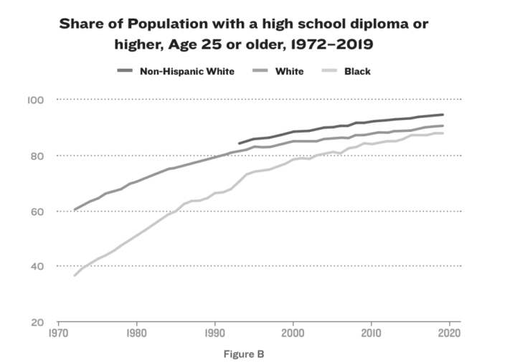
College graduation rates have also increased for African Americans. Figure C shows that among those age 25 or older, just 5.1 percent had a four-year college degree in 1972, a figure that climbed to over one in four (26.1 percent) in 2019—a fivefold increase. Over the same period, college completion also expanded for whites, but at a slower pace—more than tripling from 12.6 percent in 1972 to 40.1 percent in 2019. As a result, the relative situation of African Americans also improved over this time: In 1972 Blacks were just 40.5 percent as likely as whites to have a four-year college degree (12.6 percent for whites and 5.1 percent for Blacks), compared to 71.9 percent today (40.1 percent for whites compared to 26.1 percent for Blacks).
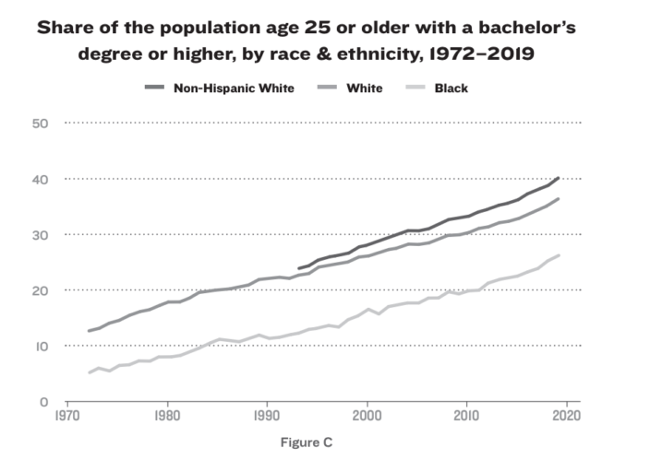
However, focusing only on the share of people with a four-year college degree obscures the broader shift to a more highly educated Black workforce. Currently, a majority of Black high school graduates (55.3 percent) go on to pursue some level of postsecondary education. More than one-fourth (29.2 percent) of African Americans age 25 or older have some college education, even if they are not bachelor’s degree holders. This includes 10.6 percent who earned a two-year associate’s degree.
Further, there is evidence that compared to white youth from families with similar income levels, Black students are actually more likely to seek higher levels of education in part because they have fewer “informal” opportunities for economic advancement, such as social networks, family relationships, and institutional mechanisms. While these investments in higher education improve employment prospects for Black college graduates relative to Black non-college graduates, on average, they do not yield outcomes equivalent to similarly educated whites.
The significant racial disparities in unemployment that are observed at each level of education (Fig D) are the strongest evidence against the notion that education or skills differentials are responsible for the Black-white unemployment gap. The Black-white unemployment rate ratio has hovered around two-to-one at every level of education for most of the last 41 years. In that time, only Black workers with advanced degrees have approached anything near parity with their white counterparts, as measured by the unemployment rate. In practical terms, this means that Black workers are not just twice as likely to be unemployed as similarly educated white workers but are often more likely to be unemployed than less-educated whites.
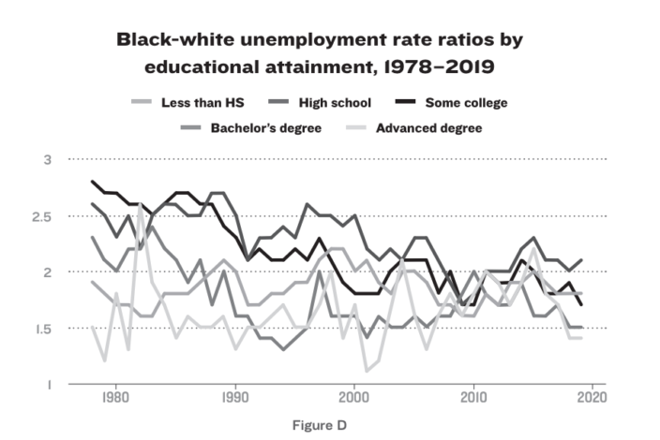
The two-to-one ratio is also remarkably consistent across age cohorts (Fig E) and among both men and women (Fig F). Patterns across age cohorts are comparable to those observed by education. Older Black workers have lower rates of unemployment than younger Black workers, but in every age cohort, Black workers remain roughly twice as likely to be unemployed as white workers.
These empirical data are consistent with field experiments revealing that Black job applicants with equivalent, and sometimes superior, credentials to white applicants are less likely to receive job call backs. Among the starkest findings in this regard is the audit study of Devah Pager, demonstrating that employers treated whites with criminal records more favorably than Blacks without criminal records.
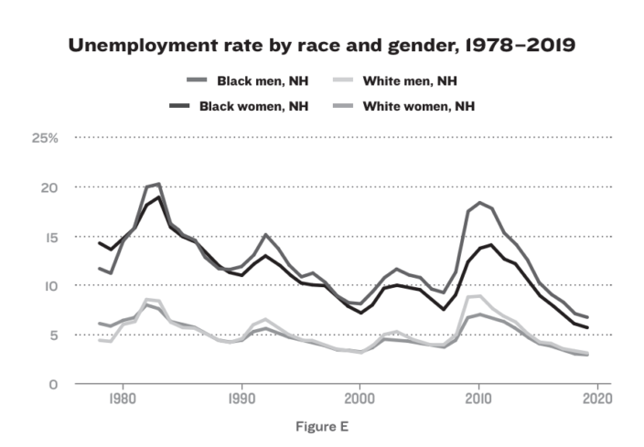
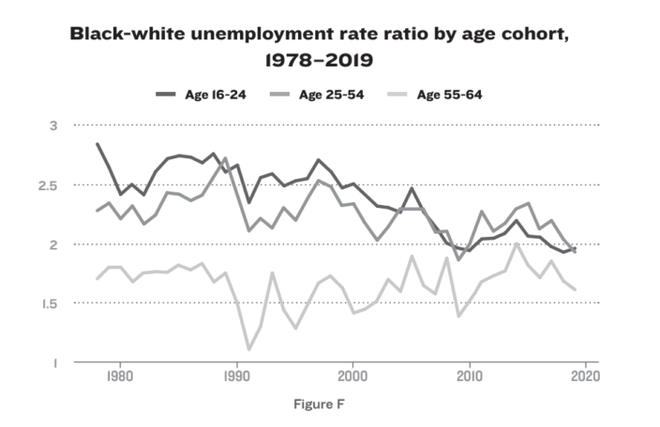
While audit and correspondence studies have been criticized for not adequately capturing unobserved characteristics that might influence hiring decisions, David Neumark has shown how robust these findings can be to such considerations. Subsequent field experiments reveal a pattern of discrimination experienced by Blacks, in particular, that has remained constant over time.
Together, these patterns strongly suggest that racial discrimination—neither inadequate education nor lack of skills on the part of Black workers—is the most plausible explanation for persistent racial disparities in unemployment. Moreover, currently observed racial differences in employment and education have been shaped by the United States’s long history of racial oppression that outright denied or severely limited Black American access to the same formal educational and employment opportunities available to whites.

Racial Disparities in Pay
Another defining feature of racial inequality in the labor market are the significant pay disparities between Black and white workers. Most empirical research on Black-white wage inequality has taken one of two approaches to estimating and explaining observed differences in pay. Trend analysis has focused on understanding the causes behind the Black-white wage gap’s four distinct periods of change: the gap’s dramatic narrowing during the latter part of the 1960s through the 1970s, the reversal of that pattern during the 1980s, the brief period of improvement during the late 1990s, and the post-2000 expansion of the gap.
The other common approach has been to examine how much of the observed pay gap between Black and white workers can be attributed to differences in so-called “cognitive skills.” In this section, we focus primarily on presenting patterns and trends in Black-white wage disparities between 1979 and 2019. We provide our review and critique of the cognitive skills and human capital literature in subsequent sections.
In 2019, the typical (median) Black worker earned 24.4 percent less per hour than the typical white worker. This is an even larger wage gap than in 1979, when the median hourly wage gap between Black and white workers was 16.4 percent. Black workers, however, face significant and growing pay penalties relative to white workers even after controlling for characteristics assumed to be related to productive capacity, like education and experience.
As shown in Figure G, controlling for racial differences in education, experience, and the fact that Black workers are more likely to live in lower-wage Southern states leaves an unexplained gap of 14.9 percent in 2019 (out of a total average gap of 26.5 percent). This is up from an unexplained gap of 8.6 percent in 1979 (out of a total average gap of 17.3 percent).
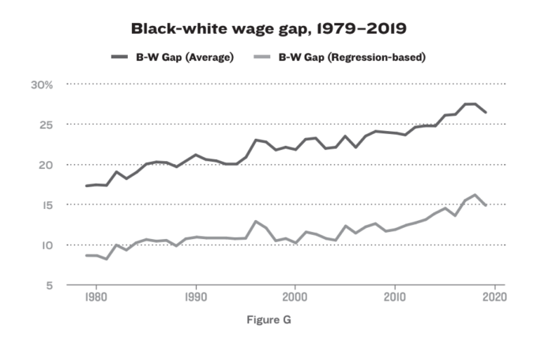
Any simple or rational explanation for this disparity is further complicated by the fact that racial wage gaps among men are significantly larger than among women. Over this same period, the unexplained Black-white wage gap among men increased 7.3 percentage points (from 8.6 percent in 1979 to 14.9 percent in 2019) and 6.8 percentage points among women. Notably, the unexplained portion of the racial wage gap among women was minimal (1.4 percent) in 1979 but had expanded to 8.6 percent by 2019.
These patterns run counter to the notion that productive capacity, as measured by education specifically, is the prevailing determinant of wages. Less than half of the observed Black-white difference in average hourly wage is explained by differences in education, experience, or region—some of the main factors presumed to determine pay. While Black-white pay differentials are smaller among women than among men, the intersection of race and gender impose much larger wage penalties for Black women relative to white men. As shown in Figure H, in 2019, Black women were paid 33.7 percent less than their white male counterparts, which was a much larger gap than that faced by either white women (25.7 percent) or Black men (22.2 percent).
The trend analysis research finds that changes in the racial wage gap track closely with changes in policy. The narrowing of the gap from the late 1960s through the 1970s can be attributed to the passage of important civil rights legislation, combined with the 1960s economic boom, active enforcement of anti-discrimination and affirmative action policy, and narrowing of the educational attainment gap between Blacks and whites. On the other hand, the widening of the gap during the 1980s was the result of retrenchment on anti-discrimination policy, growing general wage inequality, deterioration in the manufacturing sector, and a decline in union representation.
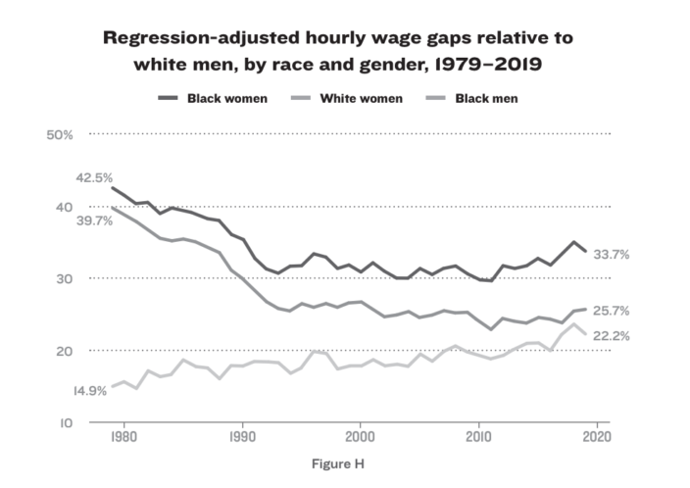
The expansion of the Black-white wage gap since the 1980s, and certainly during the post-2000 period, is also consistent with the structural trends contributing to greater wage inequality. These include: 1) limited wage growth among middle- and low-wage workers, 2) above average growth among the highest wage workers, particularly CEOs and the top 1 percent, and 3) racial inequality in hiring, pay, and opportunities for promotion that results in overrepresentation of Black workers among low- to middle-wage occupations and underrepresentation among high-wage occupations.
The divergence of productivity growth and median hourly wage growth also points to growing wage inequality in a way that challenges assumptions about competitive labor markets. In competitive labor markets, where it is assumed that employers have no power to set wages below the market wage rate and workers are paid a wage equal to their marginal productivity, productivity and wages should move together. While this was generally true in the three decades following World War II, beginning around 1973, inflation-adjusted hourly compensation (including employer-provided benefits and wages) grew at a markedly slower rate than economy-wide productivity. This pattern was documented in 2015 by Josh Bivens and Lawrence Mishel, who estimate that over two-thirds of this productivity-pay gap can be explained by rising inequality, which is characterized by greater inequality in compensation and the fact that a smaller share of national income has been going to workers relative to capital owners.
The emergence of the productivity-pay gap calls into question the assumption of wage-taking behavior on the part of employers. An emerging literature on monopsony offers a broader interpretation of employers’ power that goes beyond the simple definition of labor market concentration (i.e., the proverbial one-company town). Rather, monopsony encompasses any power employers have that allows them to cut wages without fear of losing a large share of their workers. While there are several studies estimating employees’ likelihood to exit jobs in response to wage changes, Douglas A. Webber succinctly concludes:
The majority of firms compete for workers in labor markets where the typical employee is highly unlikely to move in response to small or even modest changes in their wage. This gives these firms considerable latitude to pay lower wages without worrying about a mass exodus of employees.
Further, Ihsaan Bassier, Arindrajit Dube, and Suresh Naidu report that employers can “mark down” wages by anywhere from 20 percent to 50 percent. While evidence of rising monopsony power in the years since the late 1990s is mixed, studies consistently find that employers can exert more power over low-wage workers, affirming the link between employer power and wage inequalities.
Racial wage gaps also have widened amid the broader trend of growing wage inequality as Black workers have reaped even fewer gains from increased aggregate productivity than white workers. Figure I shows that between 1979 and 2018, median hourly real wage growth fell far short of productivity growth. While net productivity per hour worked increased 69.6 percent (1.8 percent per year) during this period, median wages grew by only 14 percent (0.4 percent per year). Over this same time, the median wage of Black workers grew at a meager 5.2 percent (0.1 percent per year) and the median wage of white workers grew 20.0 percent (0.5 percent per year).
It is also clear from Figure I that the strongest period of wage growth during this time occurred between the mid-1990s and early 2000s. The period of low unemployment and strong wage growth between 1995 and 2000 has been cited as a key contributor to some brief narrowing of the Black-white wage gap during this time, while others assert that the rise in mass incarceration during the 1990s is responsible for artificially increasing the average wage of Black men by removing a disproportionate share of those who were “less skilled” or lower-wage earners from the labor force.
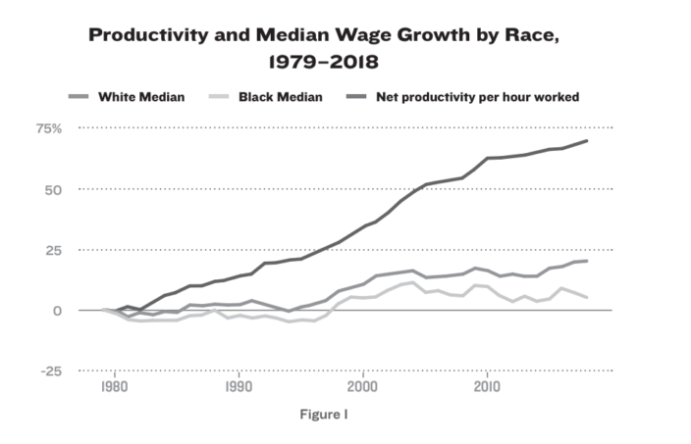

Since 2000, the Black-white wage gap has continued to widen. One of the most troubling trends of the post-2000 period has been the fact that the Black-white wage gap has grown most among workers with a bachelor’s degree. In fact, while the tight labor market of the late 1990s delivered faster wage growth to Black college graduates than white college graduates in the five-year period from 1996 to 2000, the wages of Black college graduates fell between 2015 and 2019—corresponding to the last five years of the recovery from the Great Recession, when unemployment rates were closest to those during 1996-2000 (Figure J). By contrast, the wages of white college graduates increased between 2015 and 2019.

Examples of Bargaining Power in Action
The imbalance of power between employers and employees is both a cause and consequence of the racial disparities in labor-market outcomes that we have detailed above. One of the things that gives an employee or potential employee greater leverage at the bargaining table is the existence of equally or more attractive employment alternatives—a condition that is facilitated by tighter labor markets. However, over the last four decades, there has been insufficient vigilance in fighting unemployment.
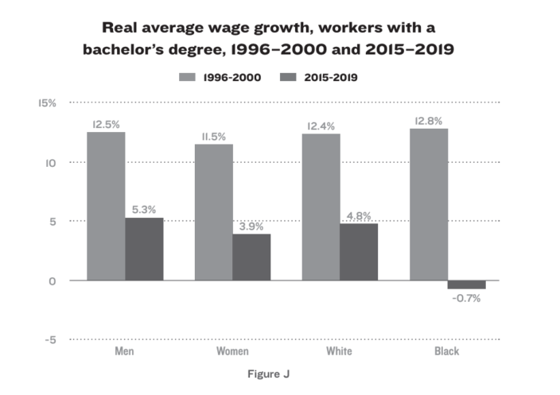

As shown in Figure K, between 1979 and 2019, the actual unemployment rate exceeded estimates of the “natural rate of unemployment” (also referred to as the non-accelerating inflation rate of unemployment or NAIRU) by an average of roughly 0.8 percentage points each year. Failure to meet even this arguably too-conservative employment target has weakened the bargaining power of the vast majority of workers, as evidenced by growing wage inequality over this period of time. Black workers have suffered some of the greatest harm from policy decisions that allowed excessive unemployment in pursuit of misguided inflation targets intended to limit wage growth.
The widening of wage gaps between Black and white workers over these same years further suggests that the perpetual two-to-one unemployment disparity further eroded Black workers’ bargaining power relative to white workers. This diminished leverage can affect a worker’s willingness to challenge unfair and unsafe working conditions given concerns about how long it may take to find another job if they were to leave or be terminated from the current job as an act of employer retaliation. Long-standing racial disparities in income and wealth also raise the stakes associated with leaving or losing a job more for Black workers than white workers.
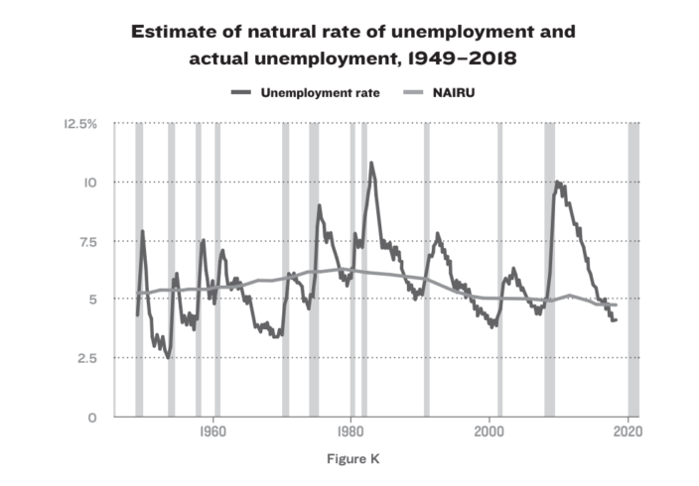

Race, Unequal Power, and the COVID-19 crisis
The COVID-19 pandemic and recession offer the most recent example of the resilience of racial inequality and stratification in the labor market and how it generates disparate outcomes and unequal bargaining power. When businesses, schools, and other public places responded to the public health crisis in mid-March 2020 by simultaneously closing their doors, three distinct groups of workers quickly emerged. The first group included tens of millions of workers who lost jobs. Workers in the second and third groups both retained their jobs, but under very different conditions.
“Essential” frontline workers were required to continue physically reporting to work, while those not in that category were able to work remotely from the safety of their homes. Black workers were least likely to be among those able to retain employment under remote working arrangements—less than one-fifth had the option to work from home, compared to almost one-third of white workers. Therefore, Black (along with Hispanic and Native American) workers were more likely than whites to suffer job loss or be compelled to put their health at risk in exchange for a measure of job security.
One of the structures contributing to such racially disparate impacts is occupational segregation, characterized by overrepresentation of Black workers, and especially Black women workers, in low-wage occupations, and underrepresentation in higher-wage occupations. The COVID-19 crisis popularized the term “essential worker,” drawing attention to the fact that Black workers occupy a disproportionate share of lower-wage jobs in major frontline industries, often with inconsistent work hours (thus, inconsistent pay) and without paid leave or employer-provided health coverage. Rho, Brown, and Fremstad report that Black workers make up a disproportionate share of frontline workers across six sectors of the economy that are considered essential.
While Black workers represent 11.9 percent of all workers, they make up about one in six (17 percent) frontline-industry workers. This includes employment in public transit (26.0 percent); childcare and social services (19.3 percent); trucking, warehouse, and postal service (18.2 percent); health care (17.5 percent); and grocery, convenience, and drug stores (14.2 percent).
Except for those in health care, none of these workers had any prior professional obligation that would require them to put their health at risk. Absent policy intervention, union representation, or a sympathetic employer, few had any assurances that they would be compensated for the increased risk.

Public Sector vs. Private Sector Racial Wage Gaps and the Role of Unions
Given the amount of power an employer holds over any individual worker, it becomes necessary to establish a countervailing force that builds sufficient power among workers through a stronger, collective voice with which to advocate for higher pay, better benefits, training and promotional opportunities, as well as protections against discrimination and harassment. In a unionized workforce, for example, collective bargaining results in labor contracts that help to create greater transparency and consistency through clearly defined policies and pay structures. These contracts play a critical role in reducing the potential for pay discrimination by limiting an employer’s discretion in paying different wages to comparably qualified individuals doing the same job and providing workers with critical protections and recourse against other forms of exploitation or mistreatment.
These conditions are less likely to exist in the private sector than in the public sector, where a larger share of the workforce is covered by a union contract. For example, 39 percent of public sector employees are in a union or covered by a union contract, compared to only 7 percent of private sector workers. Historically, the appeal of better job opportunities and greater pay equity than in the private sector has contributed to Black workers’ disproportionate employment share in the public sector as well as higher average rates of union membership. Based on empirical analysis of wages among public and private sector employees, Black workers in the public sector face smaller unexplained wage gaps than their counterparts in the private sector—6.9 percent versus 16.9 percent, respectively. Within the public sector, postal service jobs have been particularly valuable to Black workers because of the uniform wage and benefit structure (all postal employees who have the same job title and job tenure are paid the same nationwide) and higher pay relative to “comparable” private sector employment. However, since the 1980s, the postal service has been under sustained assault by those who believe the compensation provided by these jobs is too generous.
Newly developed historical data from the early post-war period affirm that collective bargaining has been an effective tool for reducing wage inequality. Based on data compiled for men in several U.S. cities in 1951, Brantley Callaway and William J. Collins found “the [union] wage premium was larger at the bottom of the income distribution than at the middle or higher, larger for African Americans than for whites, and larger for those with low levels of education,” findings that are “consistent with the view that unions substantially narrowed urban wage inequality at mid-century.”
Using data on union households from Gallup surveys dating back to 1936, Henry Farber et al. similarly found that unions raised wages “between ten and twenty log points, with the less-educated receiving an especially large premium.” While this union effect has been relatively consistent over the last 80 years, patterns of union membership have not been. Unions’ disproportionate representation of “disadvantaged” workers (i.e., not white and not college-educated) began in the mid-1940s and peaked during the 1960s. While Black workers continued to have higher rates of union membership than whites in the decades since, as overall union density has declined, rates of union membership for Black and white workers have converged.
Despite being a powerful force for increasing wages among the working class, racism within the labor movement has at times served to perpetuate rather than reduce racial inequality. While racially integrated unions have been instrumental in building support for policies that benefit Black workers, tragically, there are also examples of white workers using their unions to defend rather than defeat white supremacy.

Challenging the prevailing economic theories used to explain racial disparities in labor market outcomes
The economic theories most often invoked to explain the observed racial differentials in labor market outcomes described above are human capital theory, taste-based models of discrimination, and statistical models of discrimination. In this section, we briefly review these models and their core assumptions. We then make a case for why each of these models is historically and empirically inconsistent with the facts.

Challenges to the Conventional Wisdom of Human Capital Theory
Adam Smith first introduced the concept of human capital as having an economic value analogous to physical capital in Wealth of Nations. Building upon this concept, Jacob Mincer, T.W. Schultz, and Gary Becker popularized what we now know as “human capital theory,” formalizing a relationship between education, productivity, and earnings.
Human capital theory posits that a worker’s earnings are related, directly and solely, to their productive capacity, represented by an individual’s particular set of skills, knowledge and abilities, or human capital. Workers can increase their earnings by investing in human capital-enhancing activities that, presumably, make them more productive. While human capital investments can take multiple forms, including formal education and on-the-job training, we will focus on formal education, the most frequently studied and most often deployed explanation for observed labor market differentials between Black and white workers.
For a majority of economists, education is treated as a means of skill accumulation, which translates into greater productivity and higher compensation. However, Darity and Underwood argue that there are three major issues with the human capital theory of wages: 1) It is difficult to precisely calculate productivity, and evidence on the link between more education and increased productivity is far from definitive. 2) The huge wage differential between CEOs, or even the top 1 percent of all wage earners, and the typical “line” worker creates an important conundrum. 3) Of primary importance to the discussion outlined in this paper, the presence of labor market discrimination directly contradicts human capital theory.
Regarding the first point, the fundamental question is what is the function of higher education? Does it generally impart skill or productivity enhancing knowledge, or do credentials function as artificial entry barriers to certain occupations? Of primary concern here is the difficulty in precisely calculating one’s productivity apart from the circular move of using wages as a proxy.
We might conceive of one set of occupations where the skills-productivity nexus is consistent with the association between higher education and higher earnings, another set of occupations where the exclusion associated with gaining the credential produces scarcity that raises earnings, and a third set of professions where both factors are at play in determining earnings. The problem is there is no existing research of which we are aware that approaches the connection between higher education and higher earnings, empirically. Thus, we have no way of quantifying which or for how many jobs higher education—or education at any level—leads to a greater capacity to perform job functions. In jobs where employers rate their employees, there is considerable evidence that job performance ratings do not rise uniformly with higher levels of educational attainment for employees. Rather, in some instances there is an inverse relationship between employer ratings and employee educational attainment.
A second challenge to human capital theory lies with the mere existence of corporate “super salaries.” In 2019, the average CEO at one of the top 350 largest U.S. firms (by sales) “earned” almost 320 times the typical employee in those firms’ same industry ($21.3 million versus $66,800), constituting an increase of $2.6 million for CEOs and $1,100 for employees from 2018. If one were to accept human capital theory at face value, this differential would imply that the average CEO is 320 times as productive as the typical worker, a claim that has the ring of absurdity about it, even if there was a reasonable way to measure the difference.
But one need not consider the extreme cases of corporate executives’ huge compensation packages to recognize the difficulty of our lack of criteria for measuring productivity apart from comparative earnings. The Georgetown Center’s standard for a good job is median earnings within the occupational category of $65,000. That is consistent with the average annual compensation for tractor/trailer drivers. Is an investment banker who earns $250,000 in the same year necessarily close to four times as productive? Furthermore, if we did have a reliable independent standard for measuring productivity and found that the investment banker truly is about four times as productive, would that higher level of productivity be attributable to the banker having had a university education?
The third challenge to human capital theory is the phenomenon of labor market discrimination as evidenced by the persistence of racial disparities in wages and employment that cannot be accounted for by differences in skills. According to human capital theory, Black-white differences in unemployment and earnings can largely be explained by Black-white differences in skills or education. While empirically, higher levels of educational attainment are associated with lower average rates of unemployment and higher average wages, there is also strong evidence that the returns to educational attainment are unequal for Black and white workers.
By definition, racial discrimination results in an unfair devaluation of Black labor, since equivalently productive workers—or in the context of higher education, workers with similar advanced degrees—receive different pay. Thus, discrimination drives a wedge between any ostensible consistent relationship between wages, skills, and productivity.
Nevertheless, deniers of labor market discrimination as an explanation for the persistence of the Black-white wage gap raise questions about whether there are other unobserved characteristics that explain these differences. The literature seeking to explain the racial wage gap as a racial gap in cognitive skills has been controversial, to say the least. This body of research stemmed from cross-sectional analysis of the National Longitudinal Survey of Youth (NLSY), which included scores from the Armed Forces Qualification Test (AFQT). These AFQT scores were used as a proxy for cognitive skills in the estimation of relative wage differentials among Black and white men in their 20s and 30s. The finding that inclusion of AFQT scores in a standard human capital model substantially reduced the Black-white wage gap led some to conclude that racial discrimination in the labor market was not a significant factor in the persistence of the wage gap because racial disparities in wages could be explained by differences in cognitive skills.
The validity of that conclusion was challenged on multiple grounds. First, because there was little overlap in AFQT scores of Blacks and whites, high correlation between race and test scores presented a problem in estimating the effect on the wage gap. Using AFQT scores to explain Black-white pay gaps was also challenged on the basis of the lack of robustness to different model specifications.
Finally, the argument that there are unobserved variables that account for relatively lower skills among Black workers is inconsistent with the fact that the racial wage gap is different for men and women. In fact, given that Black women had a slight wage advantage over white women as recently as the early 1980s—something that has never been observed among men—it seems unlikely that some unobserved or unexplained pre-market force at once disadvantages the skill attainment of Black men relative to white men while providing an advantage for Black women over white women.

Challenges to the Conventional wisdom of the Taste-Based Model of Discrimination
Becker’s taste-based model of discrimination is perhaps the best-known neoclassical competitive model used to “explain” labor market discrimination. Becker’s original model has three central assumptions: (1) labor markets are competitive, and employers are motivated by profit-maximization; (2) Black and white workers are equally productive; and (3) whites have an “externally” acquired “taste for discrimination,” functioning as a preference for white workers. This model posits that discrimination is in fact intentional, if not rational, and it allows tastes for discrimination to function through three kinds of agents: employers, employees, and customers.
The biggest challenge to Becker’s taste-based model of discrimination lies in the conclusion that discriminatory wage outcomes are only temporary. In the context of Black-white wage differentials, the preference for white workers, or equivalently, the distaste for Black workers, requires Black workers to compensate discriminating employers by accepting lower wages. While the discriminatory tastes of employers, employees, or customers may create incentives for workplace segregation, in the long-run, racial wage differentials are eliminated through competition.
This conclusion is directly refuted by the historical record outlined in the first part of this essay, which demonstrates that anti-discrimination policy intervention, not market competition, was responsible for the most significant narrowing of racial wage gaps in the decade following the passage of the Civil Rights Act of 1964, and that lax enforcement of those laws in the decades since, along with other policies that weakened the bargaining power of workers, have contributed to further widening of those gaps.
A second weakness of this model is that it assumes full employment, since all job seekers are presumed hired. The set of possible outcomes then are differentiated by the racial composition of a firm’s workforce, but unemployment—the possibility that someone actively seeking employment will not be hired at all—is not a consideration.

Challenges to the Conventional Wisdom of Statistical Models of Discrimination
Statistical models of discrimination, pioneered by Phelps and Arrow, allow for less overt and unintentional means by which disparate or discriminatory labor market outcomes manifest. These models are based on the idea that employers have incomplete information about the actual productivity of individual job applicants. However, they may have beliefs about the average productivity of a given group of workers (e.g., Black workers, women, or formerly incarcerated individuals) that they assign to individuals belonging to that group. Based on those beliefs, workers belonging to the group assumed to be less productive will have a lower probability of being hired (i.e., a higher unemployment rate), or when hired, will be offered a lower wage, resulting in a wage gap.
According to statistical models of discrimination, profit-maximizing employers in an environment of imperfect information believe they can distinguish visually between candidates from groups A and B that are drawn from different frequency distributions for ability to perform. Based on the assumption that the mean of Group B’s ability distribution is markedly higher than the mean of Group A’s ability distribution, and there is little difference, if any, in the variance, these employers display a preference for members of Group B.
If, in fact, these employers are wrong and the two distributions are identical, then that fact should be learned over time. As a result, any profit-maximizing employer should become indifferent between members of Groups A and B. On the other hand, if those employers are correct, then subsequent inequalities in intergroup outcomes are due to average differences in ability, and there is no need for a theory of discrimination at all.
Confounding matters more, the informational assumption that leads employers to rely on knowledge, whether accurate or not, about group affiliation in making individual hiring decisions seems tenuous. It suggests that employers are incapable of making a sound approximation about a candidate’s future potential to perform without relying on the additional signal of group affiliation. This is implausible given the vast resources corporations devote to hiring decisions and the design of screening mechanisms. Over time, an appropriate set of questions or tests should emerge that will facilitate selection, regardless of group affiliation.
In his open letter to economists, AFL-CIO Chief Economist William Spriggs eloquently calls out the inherent racism in the statistical discrimination framework by asking, “How does a model assume that an entire set of actors, observing the infinite diversity of human beings, all settle on race as a meaningful marker independent of history, laws, and social norms? And, miraculously, those same ‘rational’ actors use ‘statistical’ methods to find only negative attributes highly correlated with race.”
In other words, the only logical reason for taking account of group affiliation or race is to discriminate on the basis for race, and not to improve the accuracy of predictions of an individual’s performance.

Stratification Economics as a Better Framework for Understanding Persistent Racial Disparities in the Labor Market
All of the aforementioned economic theories fall short in their attempts to explain long-standing racial disparities in unemployment and pay while blatantly denying the persistence of discrimination. Despite compelling empirical evidence and a solid historical record that points to discrimination as a significant factor in the persistence of racial disparities in the labor market, the interpretation of those disparities is an ongoing debate in the field of economics.
When economists get a statistically significant coefficient on race after estimating a wage equation that controls for standard measures of individual productive capacity (e.g., education, experience), macroeconomic conditions (e.g., state or regional fixed effects), as well as race and gender, what does that mean? Do we interpret that coefficient as evidence of racial discrimination, or does it reflect some unobserved or omitted variable? Devotees of the conventional economic theories described above tend to dismiss discrimination as a valid or significant explanation of the gaps in favor of the latter interpretation. But if there is some unobserved variable that would explain the statistically significant coefficient on race, it would also have to be strongly correlated with race. In its most basic form, race is nothing more than a socially constructed identifier, defined primarily by skin color in the United States— an arbitrary and superficial physical characteristic that has no relationship to one’s productive capacity. How then should we interpret that correlation?
Getting an answer to that last question requires that we go beyond our standard individual-centered models and consider structural and institutional factors, as well as what we can learn from social, psychological, and historical analyses.
In the absence of that, we continue to lean on human capital and models of discrimination to our peril. Those models have been inadequate to explain well-documented and persistent patterns of racial inequality, leading to an overemphasis on the shortcomings of individuals, and little or no emphasis on fixing biased or discriminatory systems that uphold an economic hierarchy predicated on race. This is the hole that stratification economics was developed to fill.
Stratification economics was developed in response to the inadequacy of conventional economic theory to explain intergroup inequality in general, and the persistence of racial disparities in particular. In contrast to Becker’s taste-based discrimination model, or models of statistical discrimination, stratification economics includes a set of theories or models that identify the structural processes that enable the persistence of discrimination and inequality over the long-term. This framework emphasizes the effect of group formation, group identity, and group action on an individual’s life outcomes, as opposed to a more conventional framework where individuals act solely as autonomous optimizers. Stratification economics employs an interdisciplinary approach that incorporates economics, sociology, and social psychology while proposing that one’s relative position matters. Individuals discern relative position by making both intragroup and intergroup comparisons, but a key feature of intergroup comparison is the identification of an outsider group, defined by race, ethnicity, gender, class, religion, or some other demographic characteristic.
According to stratification economics, while discrimination is unjust, it also serves the functional role of preserving hierarchy. Therefore, persistent racial inequality arises when a dominant group seeks to maintain the hierarchy that affords them some degree of social or economic privilege. Under this framework, identity can be structured so that investing in, or associating with, a group identity can lead to economic returns and benefits. This treatment of identity as endogenous represents a major departure from more conventional economic models but is consistent with a set of alternative theories for explaining stubborn racial gaps in economic outcomes that help to operationalize stratification economics. Those most relevant to the labor market context are W. Arthur Lewis’s noncompeting groups hypothesis and David H. Swinton’s labor force competition model of racial discrimination. In each of these, racial identity is associated with aspects of power and social control that are directly incorporated into the analysis.
Lewis and Swinton present models of a hierarchical wage or occupational structure and the existence of white worker “coalitions” that allow those who share this group identity to maintain a higher position in that hierarchy by limiting other (i.e., Black) workers’ access to higher-status and higher-paying occupations and funneling them into lower-status and lower-wage jobs. Their ability to exercise such an influence is based on their position as the majority group, which is a numerical and historical advantage. It is important to note that while applying racial preferences to an existing hierarchical occupational structure (i.e., occupational segregation) is discriminatory, it can be achieved without explicitly invoking or referencing race. Rather, a white worker “coalition” can essentially render excluded workers “noncompeting” by using their majority position in the firm or industry to influence the required credentials for a position, manipulate opportunities to obtain the credentials, or otherwise act as a gatekeeper over entry and promotion to preferred positions, as is often observed in professional environments, including corporate leadership, academia, law or medicine.
Thus, Lewis concludes that more direct forms of in-market discrimination only become necessary as pre-market efforts to preserve the established racial hierarchy in the occupational structure become less effective. An interesting implication of this conclusion is that investments in human capital that make members of the excluded group more qualified for preferred positions can increase the likelihood that they will experience labor market discrimination. Darity, Dietrich, and Guilkey find that while Black males were making dramatic strides in acquiring literacy between 1880 and 1910 in the United States, simultaneously they were suffering increasing proportionate losses in occupational status due to disadvantageous treatment of their measured characteristics.
Krueger’s extension of the trade-based version of the Becker model also has relevance to the discussion of racially disparate labor market outcomes. In that model, white capitalists must value racial group solidarity sufficiently to accept a lower return on their capital as the price they pay for a generally higher level of income for all whites (and higher wages for white workers). In principle, if white capitalists lose from their inability to hire less expensive Black workers, a sufficiently high relative gain in income for white workers can compensate white capitalists for their losses. This prospect advanced by Anne Krueger nearly 60 years ago fits like a glove into stratification economics’ frame of understanding discrimination as an act that yields group benefits and losses.
Further, there is an additional perverse possibility derived from stratification economics. A racial hierarchy of workers can be exploited by owners of capital to subvert worker solidarity and capture a larger share of a worker productivity as economic profit. In short, employers can potentially get away with paying Black and white workers a wage below their marginal productivity if on average, the weight white workers place on being relatively better off than Black workers is sufficiently high and white workers are paid a wage that is above that of Black workers.
Thus, both white labor and white capital jointly can benefit from discrimination against Black workers.

Conclusion
When we look at race and labor market discrimination in the context of workers’ bargaining power, it is important we recognize there are at least two complementary goals. With respect to wages, we want to shift the balance of power in a way that puts upward pressure on wages—particularly for wage earners at or below the median—and at the same time close racial wage gaps. We cannot rely on competitive markets alone to do this. Rather, interventions are required to address these inequalities. Appropriate design of those interventions requires that we expand the frameworks we use for understanding power, race, gender, and inequality so that we restructure systems and institutions to prevent discriminatory outcomes rather than enable them.
Policies geared toward maximizing employment and limiting the depth and duration of recessions are essential to establishing a new balance of power that makes workers less vulnerable to limited job prospects and low wages. For many of the reasons we have already discussed, these policies are particularly important to improve outcomes of Black workers. During the last four decades, the Fed’s monetary policy decisions have been too contractionary, and those decisions have limited wage growth for the bottom 80 percent of workers and had an adverse effect on closing the Black-white wage gap. While recent revisions to the Federal Reserve’s long-run goals and monetary policy strategy reflect some acknowledgement of the role the central bank plays in reducing or exacerbating racial economic inequality, unless there is an ongoing commitment to avoid prematurely enacting policies that needlessly limit job growth and disproportionately harm Black workers, the balance of power is unchanged. Similarly, Congress must avoid excessive and unnecessary fiscal austerity and utilize their power to target funding for job creation in ways that promote racial equity, including a federal job guarantee. A federal job guarantee would eliminate the need for economists to squabble over the full employment unemployment rate, and essentially end the tradeoff between unemployment and inflation by making the Phillips curve vertical at a zero unemployment rate.
Labor unions play an important role in giving workers a stronger, collective voice to advocate for higher pay, better benefits, training and promotional opportunities, as well as protections against discrimination and harassment. The PRO Act is an important step toward streamlining the process when workers form a union, ensuring that they are successful in negotiating a first agreement, and holding employers accountable when they violate labor law. Historically, when given an opportunity to join a union, Black workers have had the highest rates of union membership and have benefited from better pay and working conditions relative to workers who are not covered by a union contract. Still, the labor movement, like any other U.S. institution, is not immune to racism and unions must continue to grow as more diverse, inclusive, and dynamic organizations as they serve the vital role of leveling the playing field for all workers.
Finally, the fact that labor market discrimination has persisted well beyond the passage of Title VII of the Civil Rights Act of 1964 and establishment of the EEOC, the federal agency tasked with enforcement of federal anti-discrimination laws, should not be overlooked, or taken lightly. As outlined in Yang and Liu, meaningful accountability for discrimination requires solutions that confront the power and information asymmetries that weaken our enforcement system. Specifically, the authors recommend changes in at least four areas: (1) Policies that encourage employer transparency, such as requiring employers to report employment and pay data by race, ethnicity, gender, and occupation, are necessary to fight discrimination and encourage accountability. Regular reporting draws attention to discriminatory patterns, but also empowers workers with the information they need to pursue recourse against workplace discrimination. (2) Increased funding of federal, state, and local enforcement agencies is necessary to provide the staffing and resources required to investigate the tens of thousands of discrimination charges filed each year and level the playing field for workers seeking justice. (3) Revising legal doctrines to better align with the language and purpose of Title VII and other anti-discrimination laws will help to relieve the exceptionally onerous burden workers face in proving cases of discrimination. (4) Legal protections against anti-discrimination should be expanded to cover all workers and protect against practices that coerce employees to waive any rights to legally challenge unfair or unequal treatment.
The pursuit of economic and racial justice requires a serious interrogation of long-accepted assumptions about how the labor market functions and how much power any individual worker has to choose a better alternative. For Black workers, there is also a long history of racially motivated exclusion, exploitation, and oppression that contributes to the assumed inferiority of Black labor and normalization of racial inequality. Therefore, meaningful policy changes that will serve to empower all workers and eliminate persistent racial disparities in the labor market also require a serious reckoning with the pervasiveness of racism in the collective thought, actions, institutions and polices of the United States.

Read more about Discrimination Jobs Racism workers
Valerie Wilson is director of the Economic Policy Institute’s Program on Race, Ethnicity, and the Economy.
William Darity Jr. is the Samuel DuBois Cook Professor of Public Policy, African and African American Studies, and Economics at Duke University.

